Control Systems Laboratory

Hardware and Software Installation

Objectives
- Install MATLAB 2024a; Simulink; and Control Systems, Symbolic, and Optimization toolboxes.
- Install the Arduino support package.
- Verify and test hardware (done in class).

Table of Contents
Objectives 1
Part 1: Install MATLAB 2024a 2
Part 2: Arduino Toolbox Installation for Simulink 4
Objective: 4
Simulink Arduino Library Installation: 4
Part 3: Arduino Hardware Setup 6
Troubleshooting: 10
How do I find what COM port my Arduino is? 10
How do I Get back to this hardware verification page if I need to check it later? 11
Access Denied error, or failed compile error 12
Do NOT have spaced in any folders or any file names - directory of file not found 12
Red block in Simulink diagram: 12
Error about board not connected to computer 13
Error Dialog. Error using open… Simulink diagram file name has parenthesis in it 15
Error “The system cannot find the file specified.” 16

Part 1: Install MATLAB 2024a
- Install MATLAB 2024a – you MUST use 2024a for this course. Files will not be compatible with previous versions.
  - Go here and follow the instructions:
https://itssc.rpi.edu/hc/en-us/articles/360004815472-Matlab-Campus-wide-Install
  - Use the instructions provided and install MATLAB 2024a.
    - The only products you need to install are MATLAB, Simulink, Symbolic Math, Control System, and Optimization Toolboxes.
Do NOT install other tools unless you need them. Installing all the packages can lead to compatibility issues.
- Find the “Documents/MATLAB” folder
  - During installation MATLAB should have created a “MATLAB” folder in your Documents folder. Find this folder, for example my folder is located at “C:\Users\hurstj\OneDrive\Documents\MATLAB”: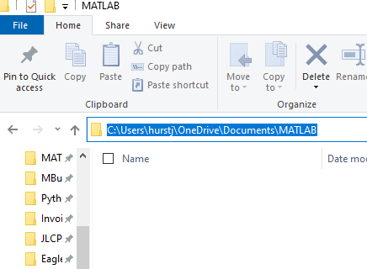
Note: this is NOT the where the program is installed (C:\Program Files\...)
  - Next open MATLAB and verify that MATLAB knows where this folder is located by typing “path” in the command line. Usually, MATLAB will open in this directory by default the first time it opened. Scroll all the way to the top and you should see your directory as the first item in the path:
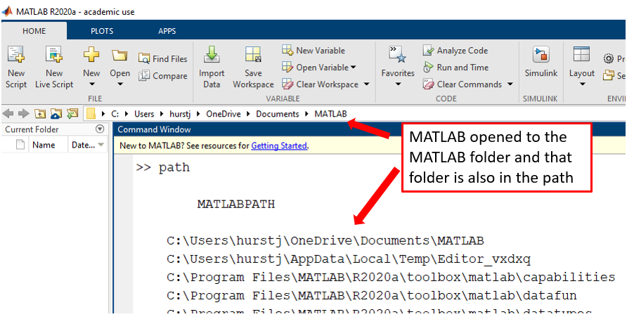
This location is usually referred to as the “MATLAB folder”, located in your Documents folder, and this is where we will keep all the files.

- Create a “Compile” folder in your Documents\MATLAB folder (Not where the program is installed i.e. C:\Program Files\Matlab.)

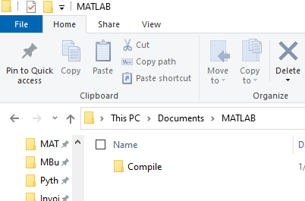

This is where MATLAB will put any extra files and code used for our labs. This folder is for MALTAB to use; you will not be putting anything in the folder.

- Specify to Simulink that it should put all the files used for code generation in the “Compile” folder.
  - Open Matlab 2024a. From the top Ribbon select “Preferences”, “Simulink”, “Open Simulink Preferences”, “General”. And specify the “Simulation cache folder” and the “Code generation folder” to be the Compile folder you created in the previous step.
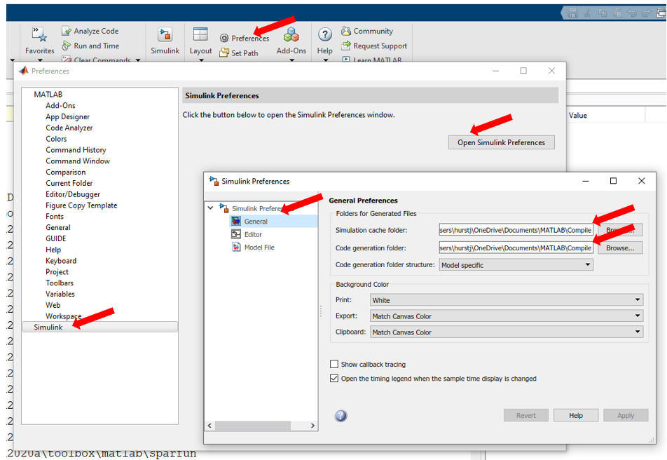
Now when Simulink needs to create extra files and folders (which it will do a lot) they will always be created in the same folder, and it will keep our MALAB folder clean without all extra compiling files.

Part 2: Arduino Toolbox Installation for Simulink

Objective:
- Install Arduino software package for Simulink.
- Verify the Installation
- Install the USB Drivers for the Arduino board

Simulink Arduino Library Installation:
- Open MATLAB by right clicking the icon and selecting “Run as Administrator”
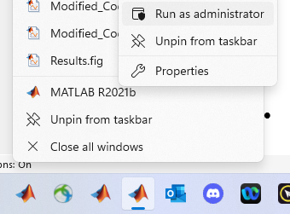
- Click Add-Ons (under the “HOME” tab):

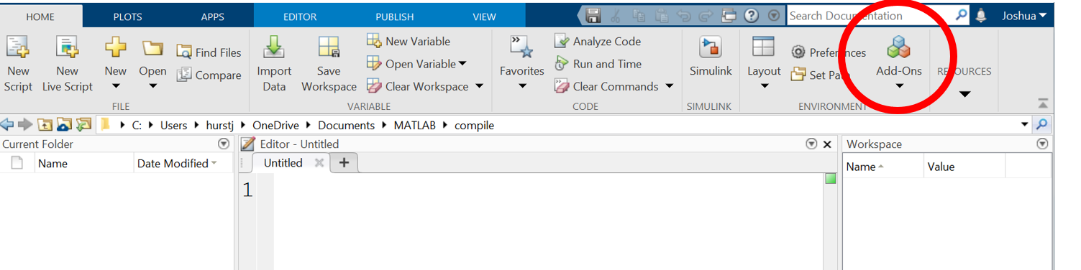
- The add on explorer window will appear. Under “Filter by type” select “Hardware Support Packages” then “Simulink Support for Arduino Hardware”: (you can also type “Simulink Support for Arduino Hardware” in the ‘search for addons’ box if you have trouble finding it).
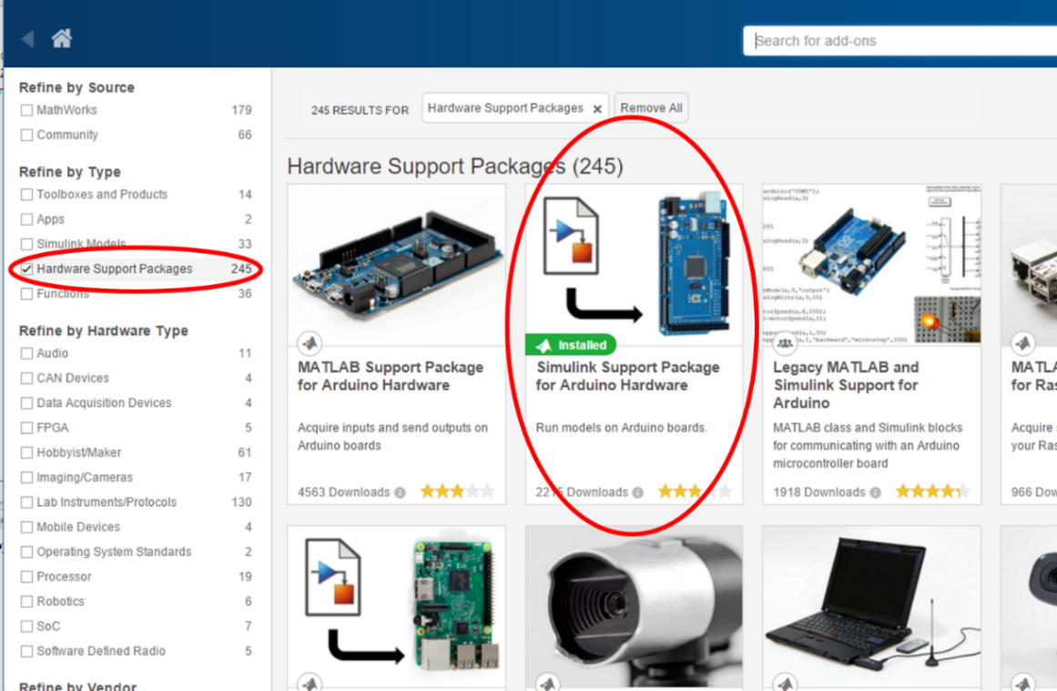
- When prompted, log in using your MathWorks credentials. If you do not have an account, you will need to create one.
- Follow the onscreen prompts to install the library. (Takes 5-15 minutes)

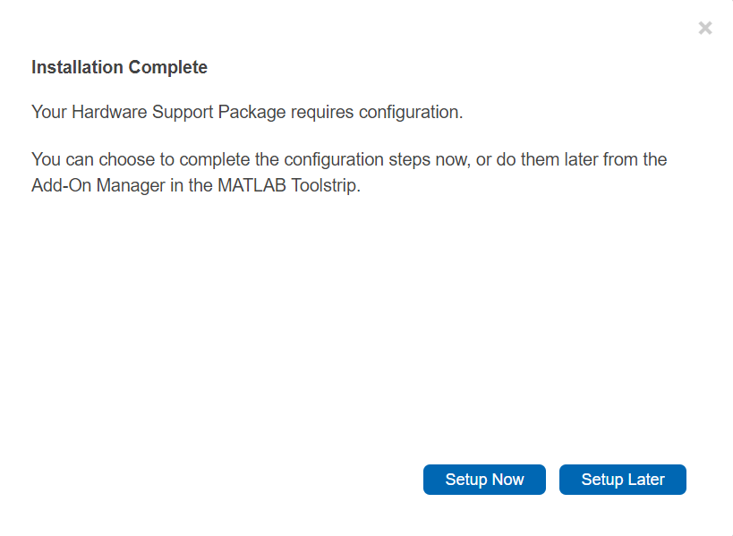
If you do not have hardware select “Setup Later” and software installation is finished until you have the hardware.

Part 3: Arduino Hardware Setup

- Open MATLAB 2024a. From the MATLAB window select “Add-Ons”, “Manage Add-Ons”, and click the gear icon for the Simulink Support Package for Arduino Hardware.
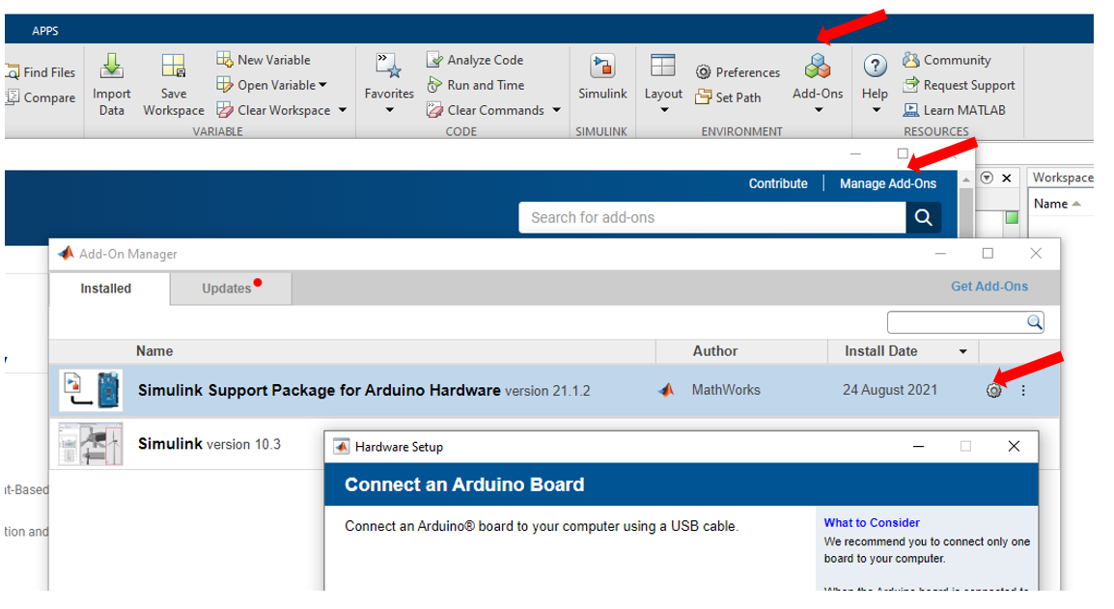
- Leave the default boards selected and select “Next” for the following 3 screens:
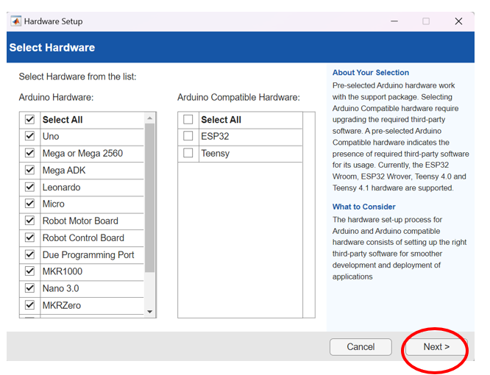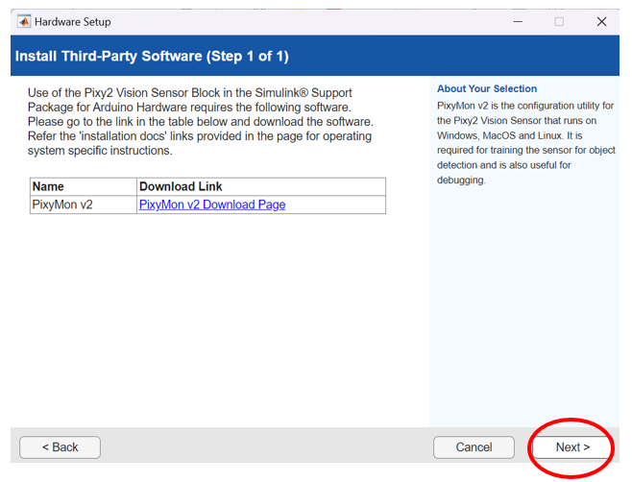
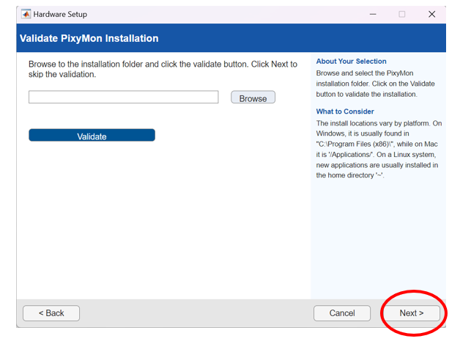

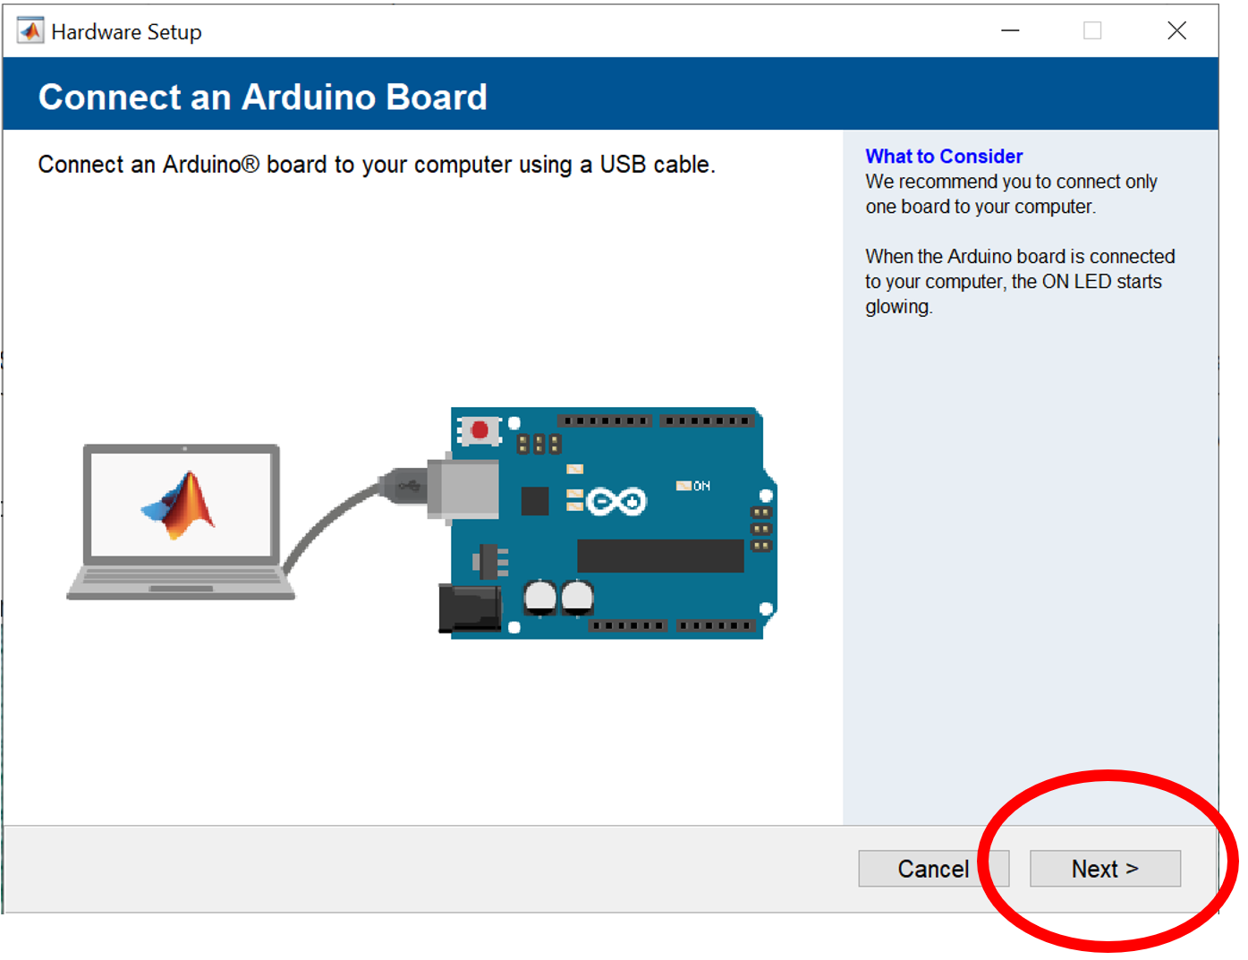
Make sure your board is plugged in and select Next. It will take a couple minutes before getting to the next screen. The next screen may automatically detect your board and show up as “Arduino Mega or Mega 2560” in which case you can select “Next”.
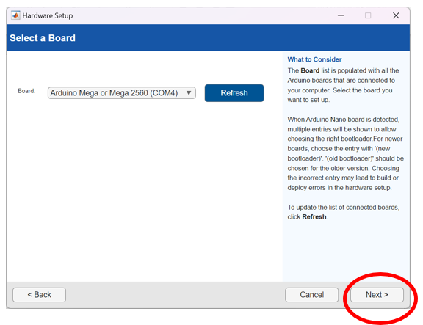
If it does not show up click “Arduino Drivers Installation” and follow the steps in that link. You will be looking for a USB Serial device or similar name when you follow the steps on that webpage.
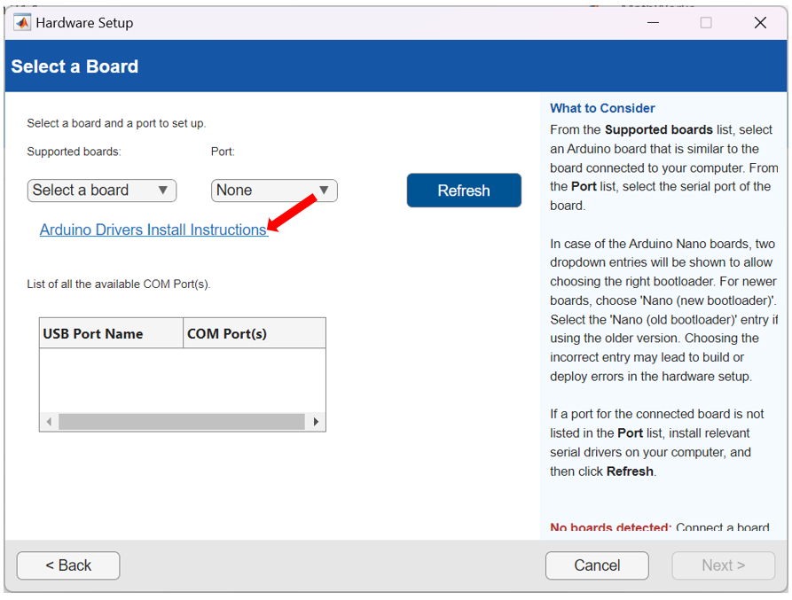

If it does not show up click “Refresh”, find the com port number that has “Serial Port (USB)”, then in the drop down menu select “Mega or Mega 2560” and “COM#” where the # is the number show in the “Serial Port (USB)” in the table.
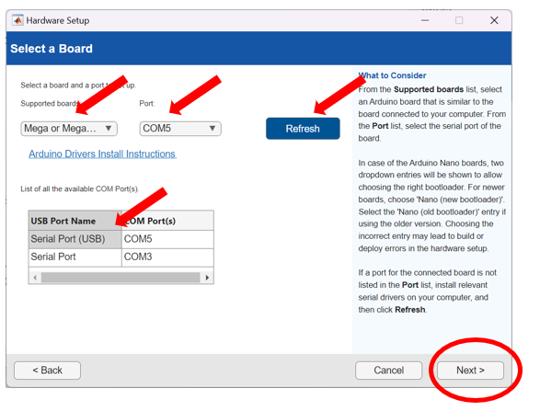

Click Next to verify the setup.

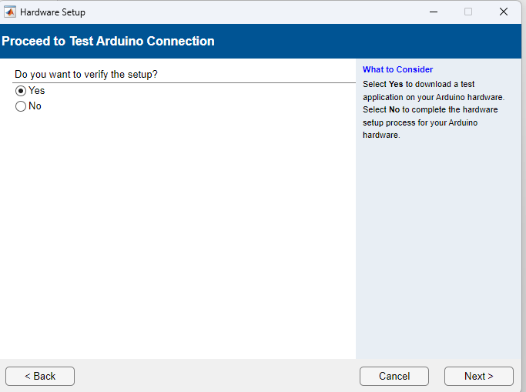

Allow the Java. Verify it builds and downloads:

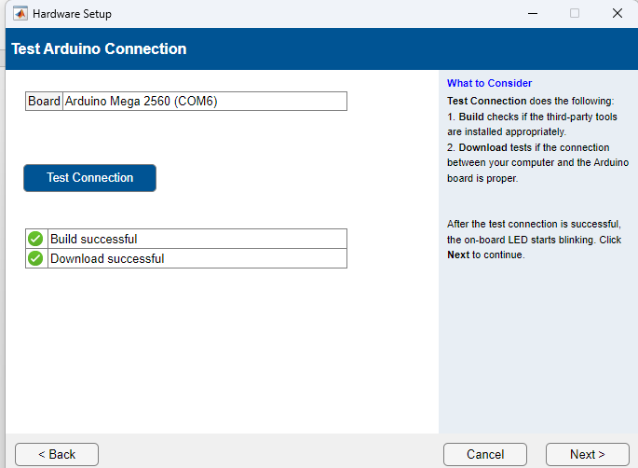

You are now ready to use your hardware.

Troubleshooting:

How do I find what COM port my Arduino is?
Press windows key, type “device manager”, scroll down to Ports, and expand. Connect the USB cable to the computer and see what device it shows. It should read “Arduino Mega 2560” or “USB-SERIAL CH340”. If it does not right click on the device and select “update driver” and search automatically. After this is done disconnect and reconnect the USB cable.
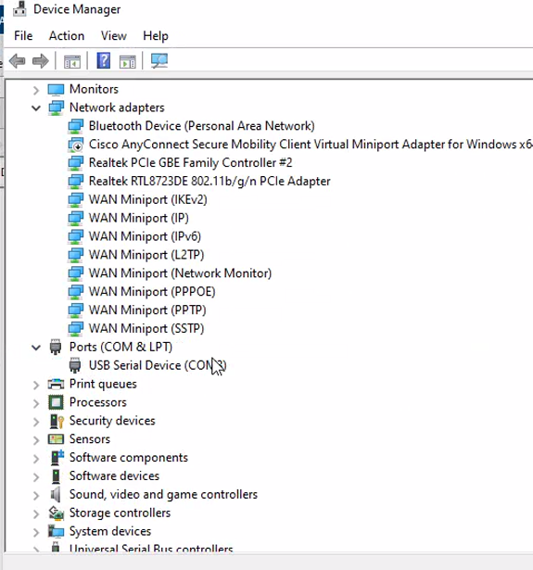

How do I Get back to this hardware verification page if I need to check it later?
From the MATLAB window select “Add-Ons”, “Manage Add-Ons”, and click the gear icon for the Simulink Support Package for Arduino Hardware.


Access Denied error, or failed compile error
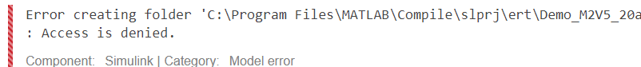
If there is an “access denied” error or compiling error try restarting MATLAB by right clicking the icon and selecting “Run as Administrator”

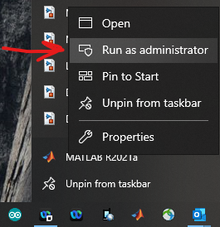

Do NOT have spaced in any folders or any file names - directory of file not found

If you get a compile error or directory not found make sure MATLABs working directory, and the folders and file names of the Simulink diagrams do not have spaces in them.

Red block in Simulink diagram:

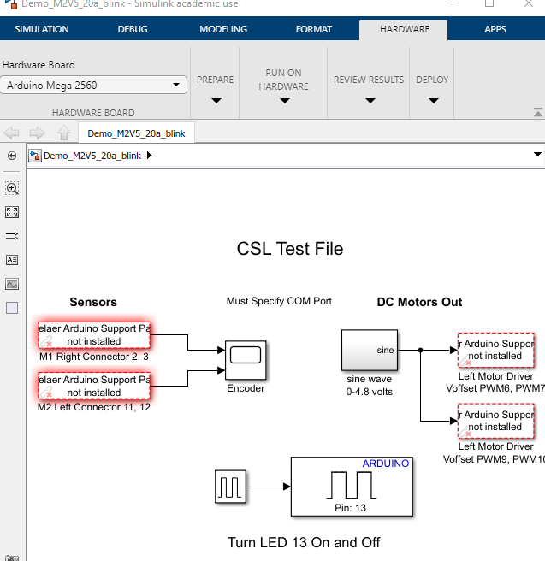

The Arduino Support package is not properly installed. Follow the pre-lab instruction carefully.

Error about board not connected to computer
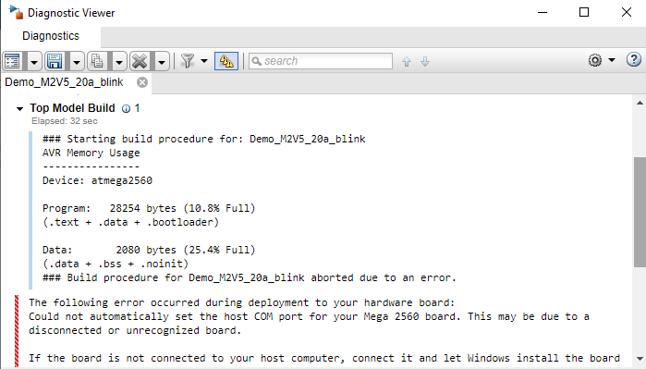
First Check that board is recognized by your computer:
Press windows key, type “device manager”, scroll down to Ports, and expand. Connect the USB cable to the computer and see what device it shows. It should read “Arduino Mega 2560”. If it does not right click on the device and select “update driver” and search automatically. After this is done disconnect and reconnect the USB cable.


If it still does not “Arduino Mega 2560” take note of the COM port number. Open MATLAB and in the command line type:
codertarget.arduinobase.internal.getArduinoIDERoot
Copy the resulting path. Then right click “USB Serial Device” and select “update driver” then “Browse my computer for driver software” then past the copied path and select Next. The deivce should now show ups as Arduino mega.
If it still does not show up, then in the Simulink diagram click “Hardware Settings”, “Hardware Implementation”, expand the “Device Details”, “Hardware board settings”, “Target hardware Resources”, “Host Board connection”, then “set host Com port” to “Manually” and specify the com port number.
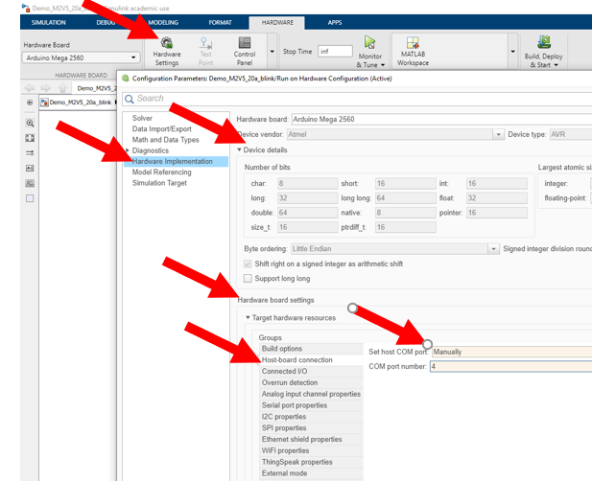

Error Dialog. Error using open… Simulink diagram file name has parenthesis in it
- Make sure the Simulink diagram does not have parenthesis in it (which can be caused by downloading the file twice).
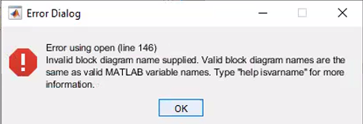
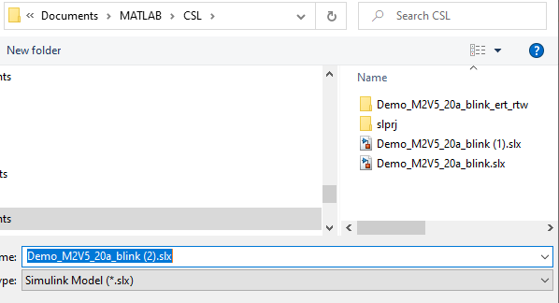

Error “The system cannot find the file specified.”
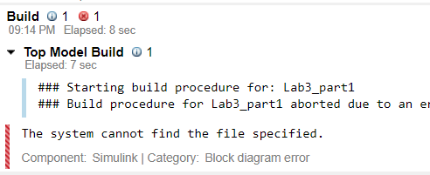
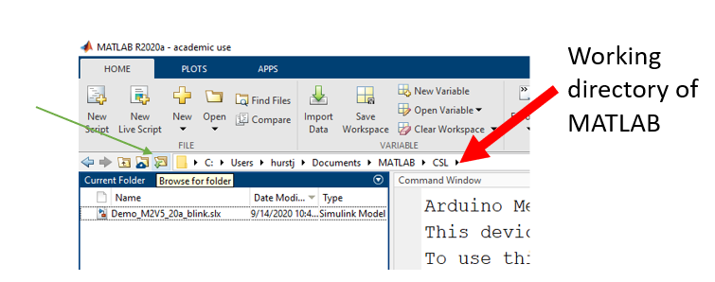
  - Make sure the working directory of MATLAB is in your documents folder.

